[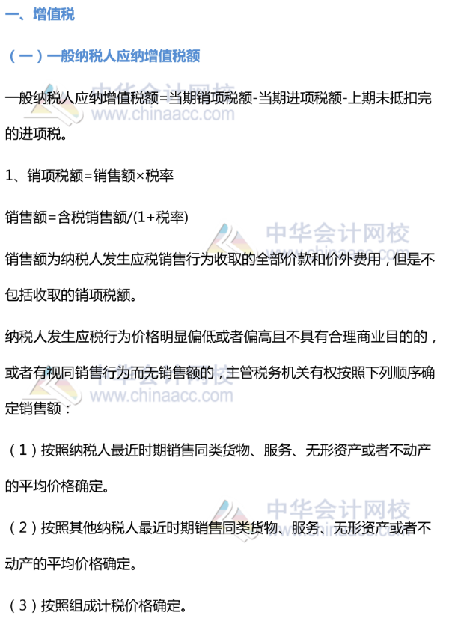](http://www.chinaacc.com/upload/resources/image/2019/03/20/53335.png)

[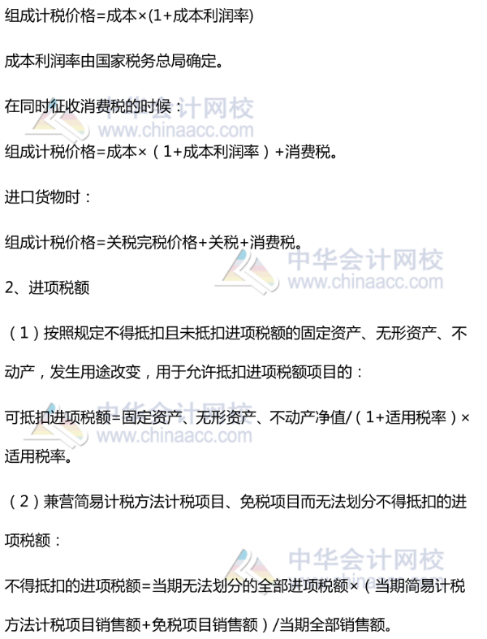](http://www.chinaacc.com/upload/resources/image/2019/03/20/53337.png)

[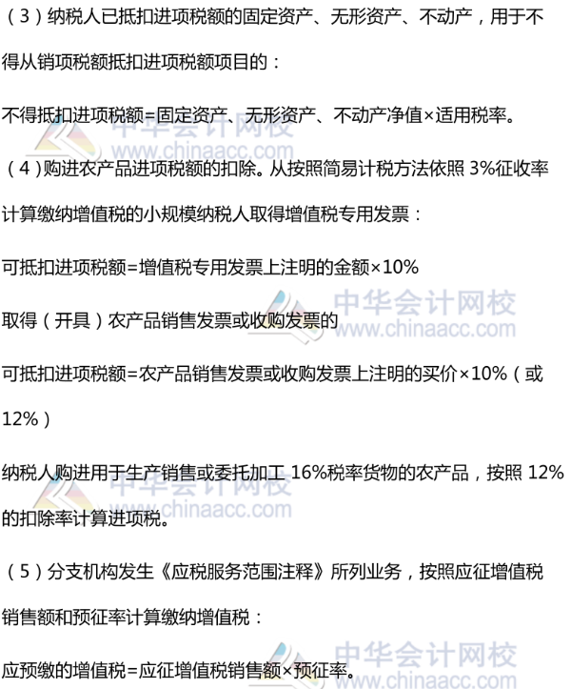](http://www.chinaacc.com/upload/resources/image/2019/03/20/53339.png)

第一章我们了解了全税种计算公式增值税中的一般纳税人应纳增值税额

本章我们了解一下增值税中的小规模纳税人应纳增值税、进口货物应纳增值税额、出口货物退（免）税

[](http://www.chinaacc.com/upload/resources/image/2019/03/20/53342.png)

[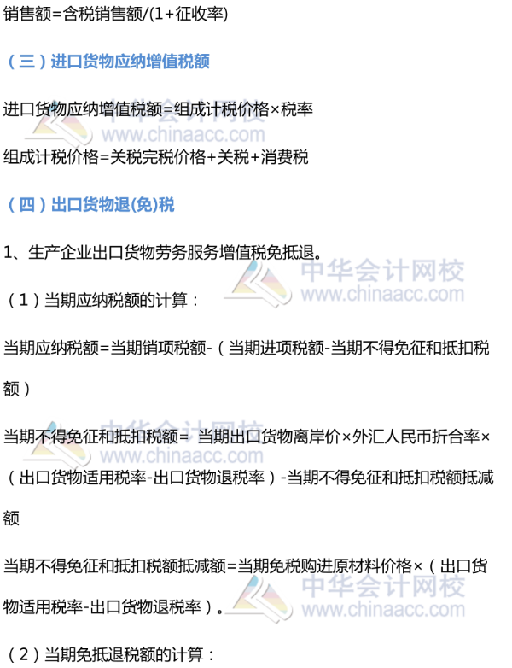](http://www.chinaacc.com/upload/resources/image/2019/03/20/53348.png)

[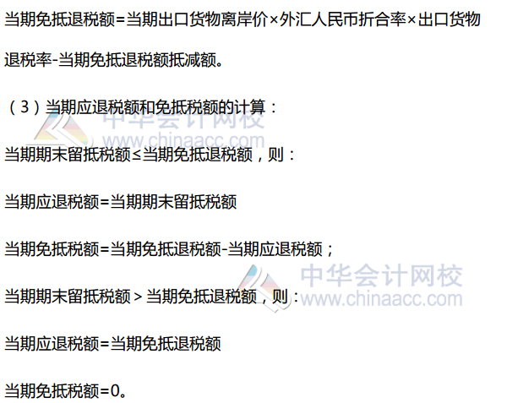](http://www.chinaacc.com/upload/resources/image/2019/03/21/54010.png)

全税种计算公式（三）— 消费税额

[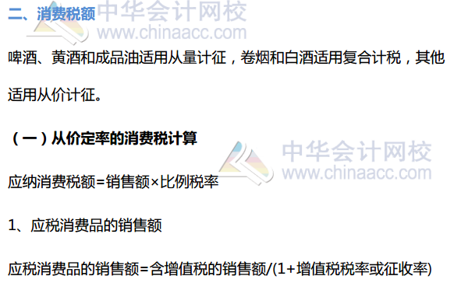](http://www.chinaacc.com/upload/resources/image/2019/03/21/54016.png)

[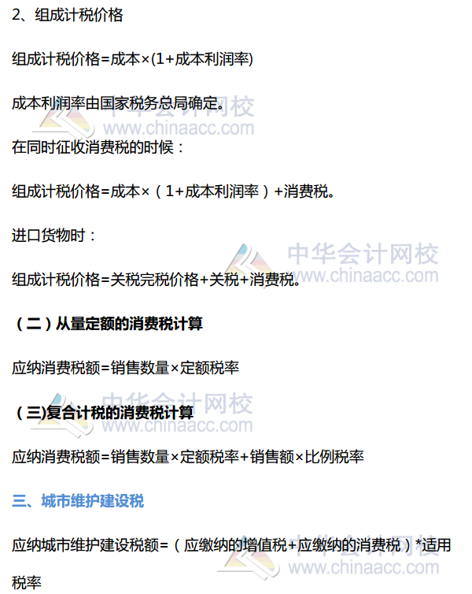](http://www.chinaacc.com/upload/resources/image/2019/03/21/54015.png)

**教育附加、烟叶税-资源税**

[](http://www.chinaacc.com/upload/resources/image/2019/03/18/52397.jpg)

[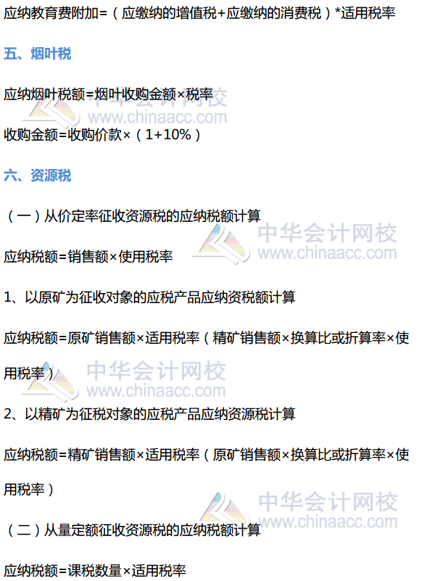](http://www.chinaacc.com/upload/resources/image/2019/03/21/54050.png)

**车辆购置税、土地增值税**

[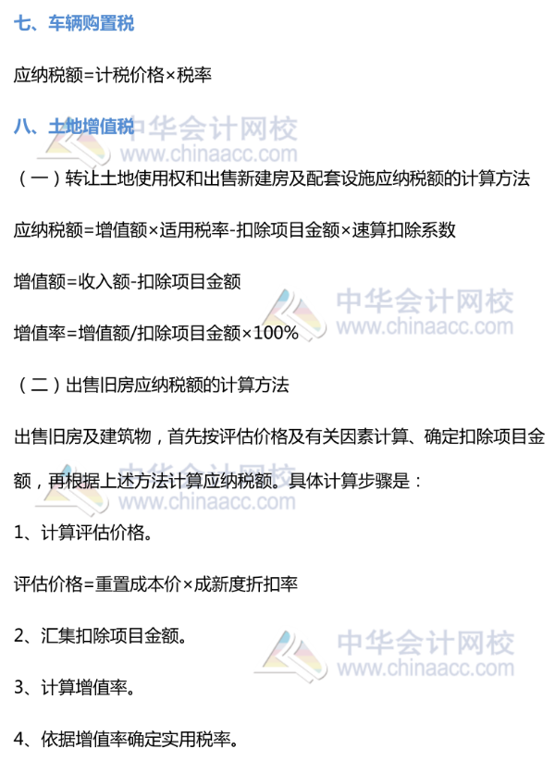](http://www.chinaacc.com/upload/resources/image/2019/03/19/52975.png)

[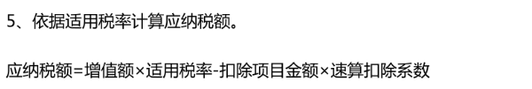](http://www.chinaacc.com/upload/resources/image/2019/03/19/52976.png)

[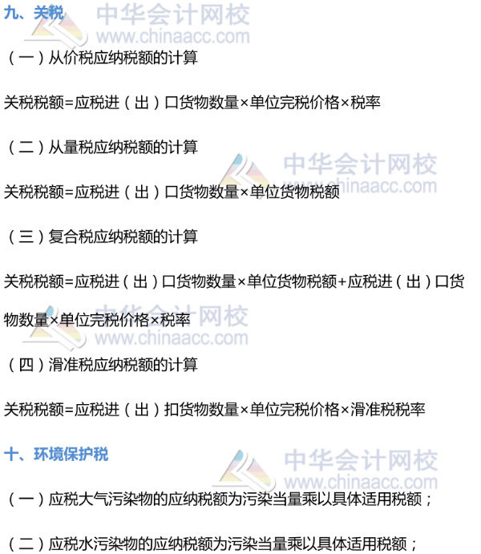](http://www.chinaacc.com/upload/resources/image/2019/03/19/52998.png)

[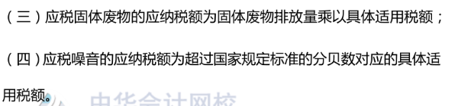](http://www.chinaacc.com/upload/resources/image/2019/03/19/53000.png)

**企业所得税**

[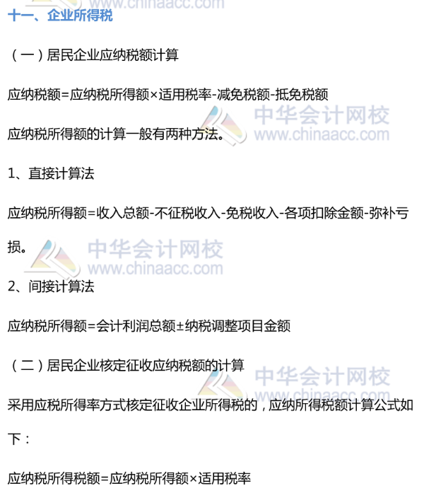](http://www.chinaacc.com/upload/resources/image/2019/03/19/53014.png)

[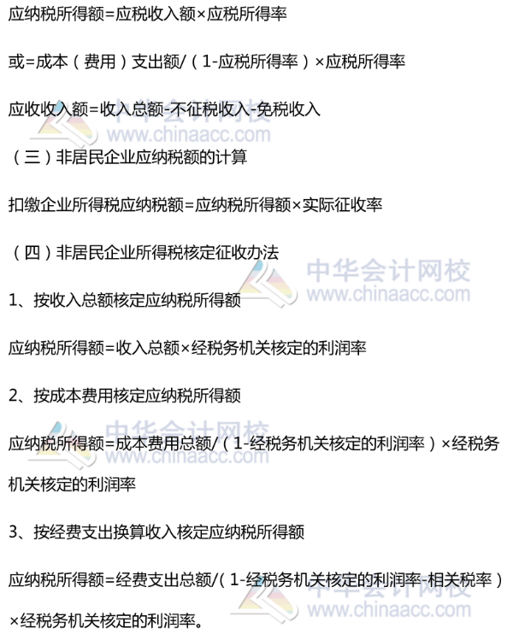](http://www.chinaacc.com/upload/resources/image/2019/03/19/53016.png)

**个人所得税**

[](http://www.chinaacc.com/upload/resources/image/2019/03/19/53027.png)

[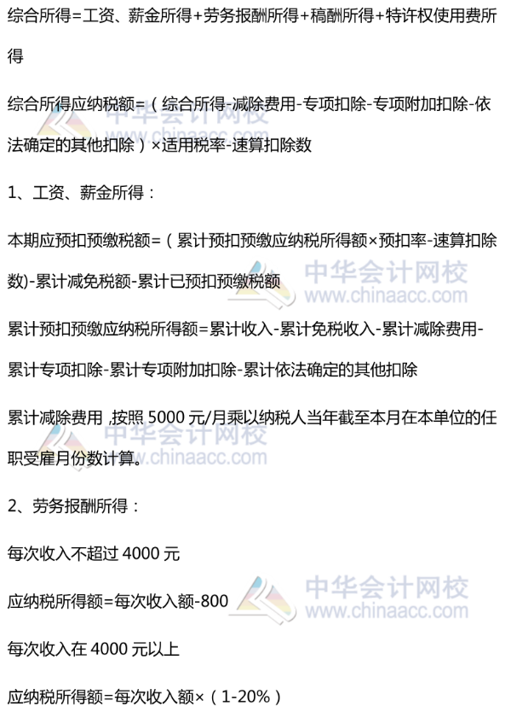](http://www.chinaacc.com/upload/resources/image/2019/03/19/53066.png)

[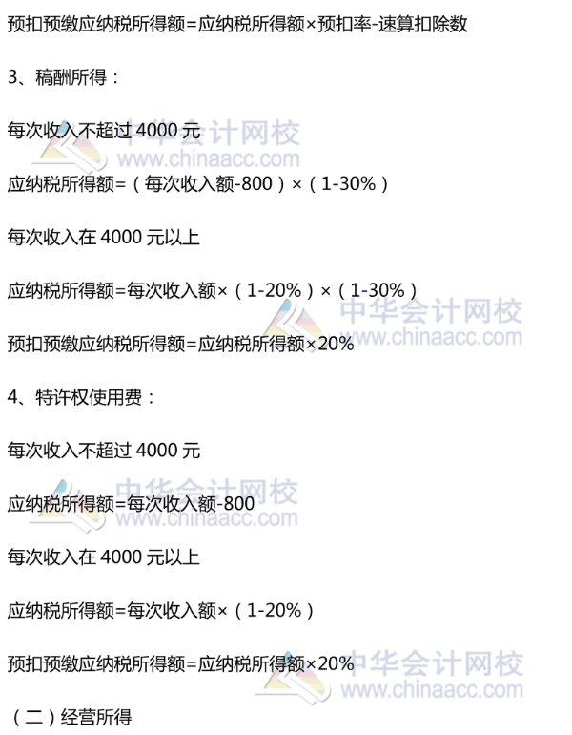](http://www.chinaacc.com/upload/resources/image/2019/03/19/53032.png)

[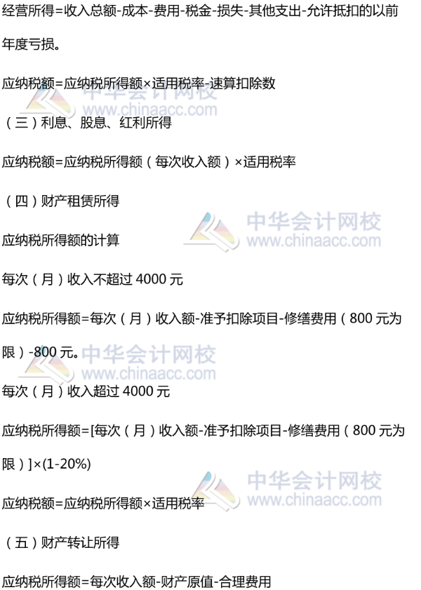](http://www.chinaacc.com/upload/resources/image/2019/03/19/53034.png)

[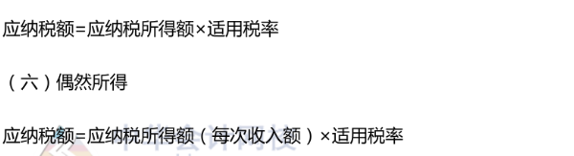](http://www.chinaacc.com/upload/resources/image/2019/03/19/53039.png)

**印花税、房产税**

[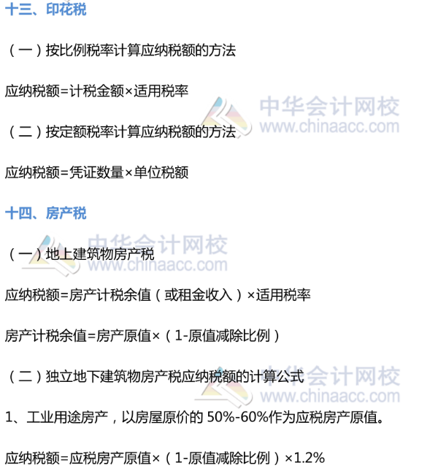](http://www.chinaacc.com/upload/resources/image/2019/03/19/53078.png)

[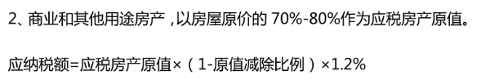](http://www.chinaacc.com/upload/resources/image/2019/03/19/53080.png)

**车船税、契税、城镇土地使用税、耕地占用税、船舶吨税**

[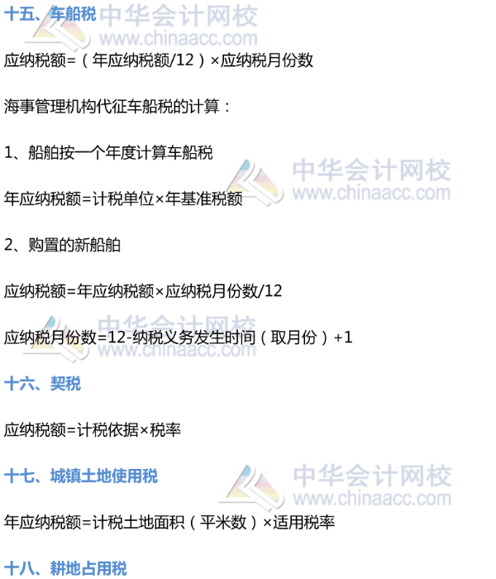](http://www.chinaacc.com/upload/resources/image/2019/03/19/53083.png)

[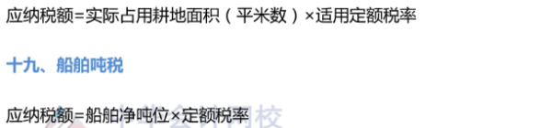](http://www.chinaacc.com/upload/resources/image/2019/03/19/53085.png)